Gabriel Martinez
WES 267B
Homework 2

Assignment 2 Report
The below shows the Lab and Homework two results and outputs.

Lab 2 Report: Loop unrolling
- How do we handle when there is not at least four elements remaining?
  - Answer: We have to manually loop through the elements. Case 1: if there’s less than four elements then we have to loop over the remaining elements in this case 0,1,2. Case 2: If there’s any amount over a multiple of four then we have to keep track of the index, i, such that we loop from i to the remaining number of elements in the array. Example, if there’s 7 elements then i=4 and have to loop 4,5,6.
- What is happening at the instruction level that may make this more efficient?
  - Answer: According to The Clang project docs, unrolling a loop reduces the loop control overhead and exposes more opportunities for instruction level parallelism [1].

Loop output
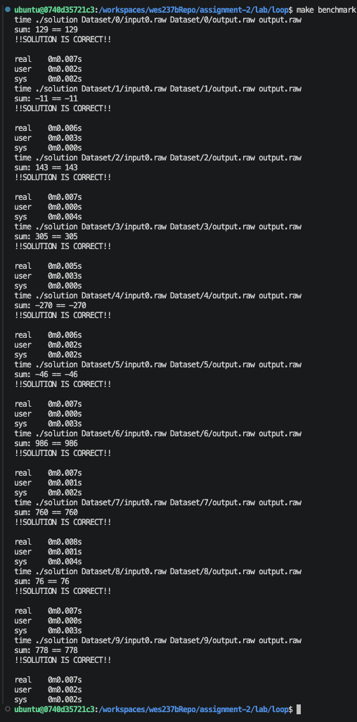

Loop unrolling output
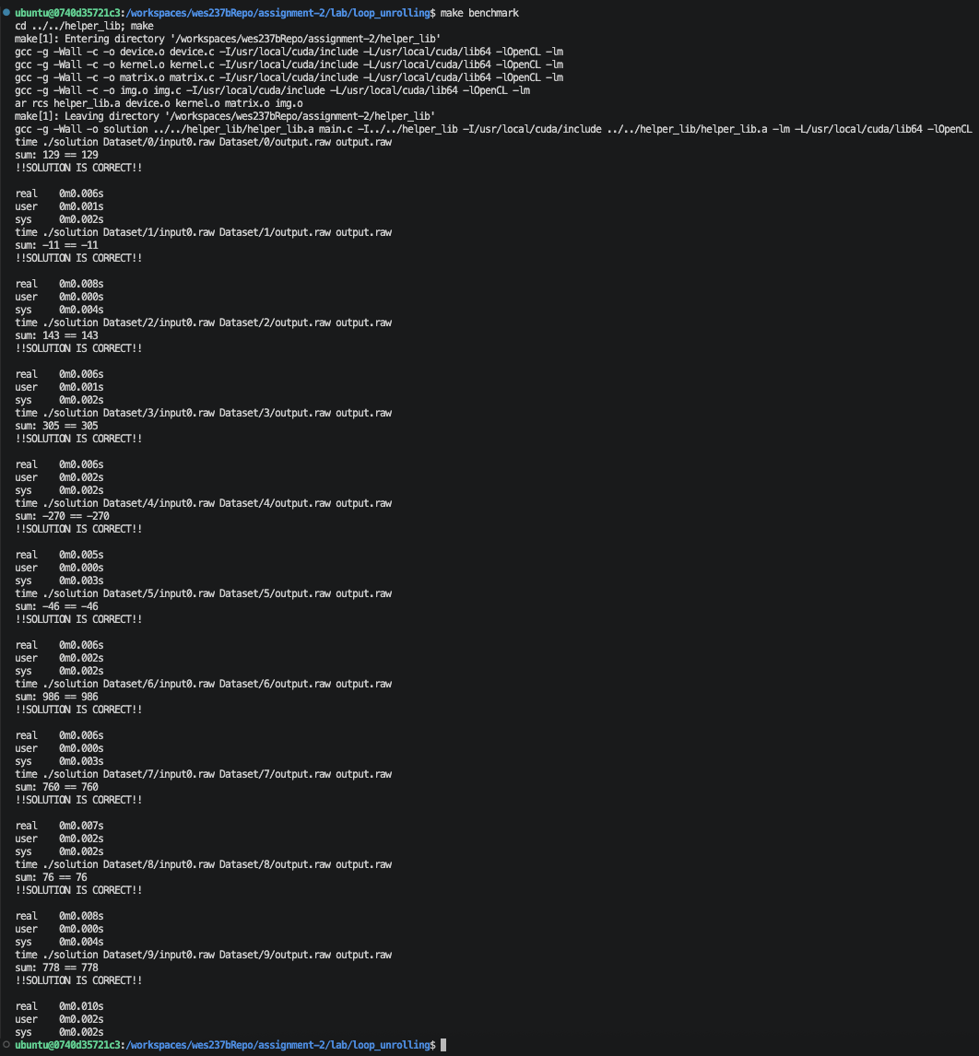

Homework 2: Report
Takeaway,

Naïve Matrix Multiply Output
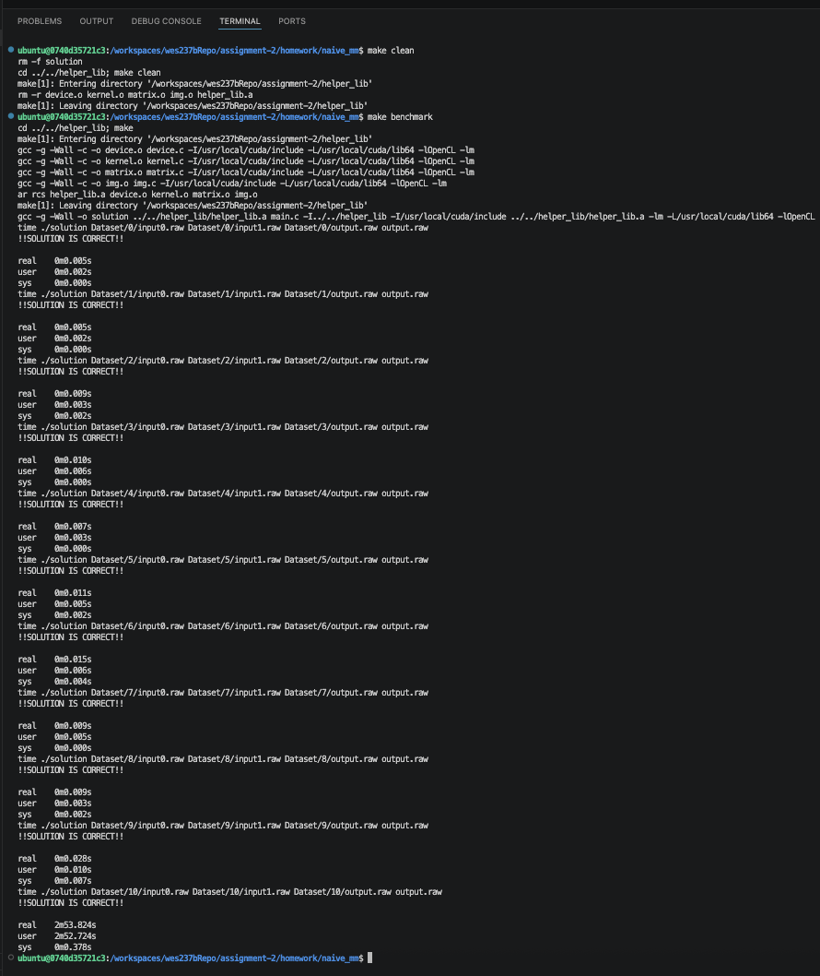

Block Matrix Multiply Output

8 Block Size
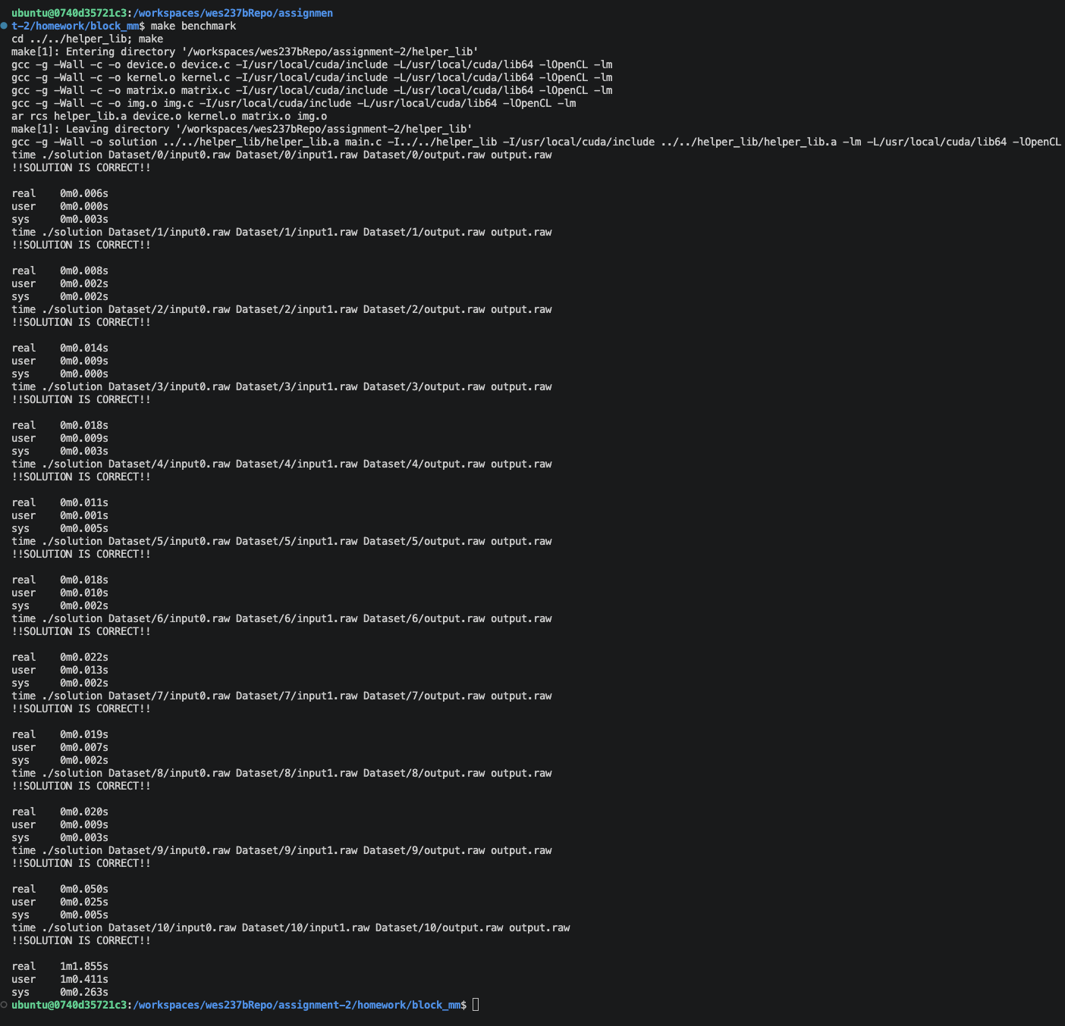

16 Block Size
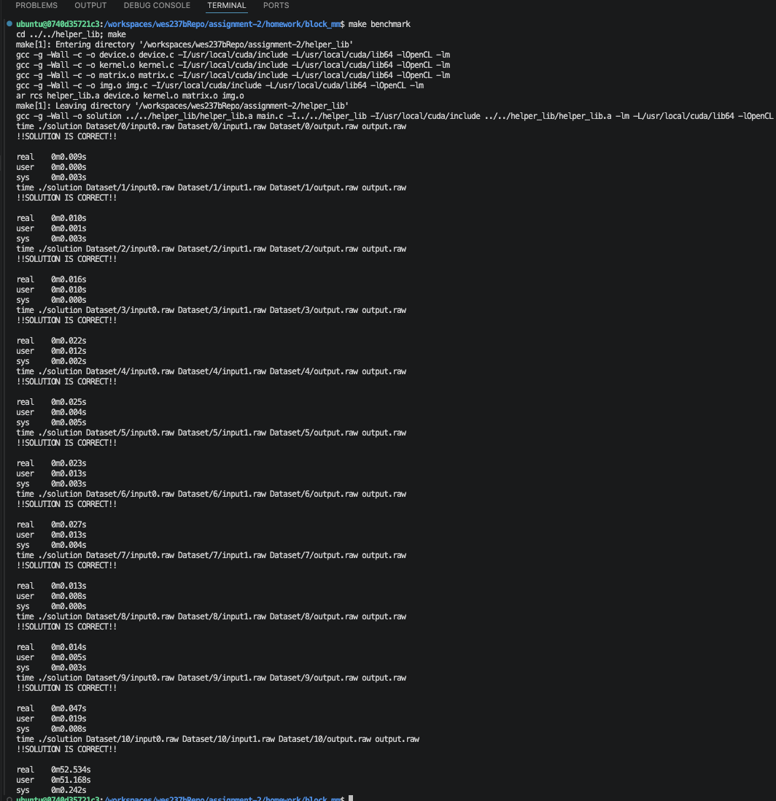

32 Block Size
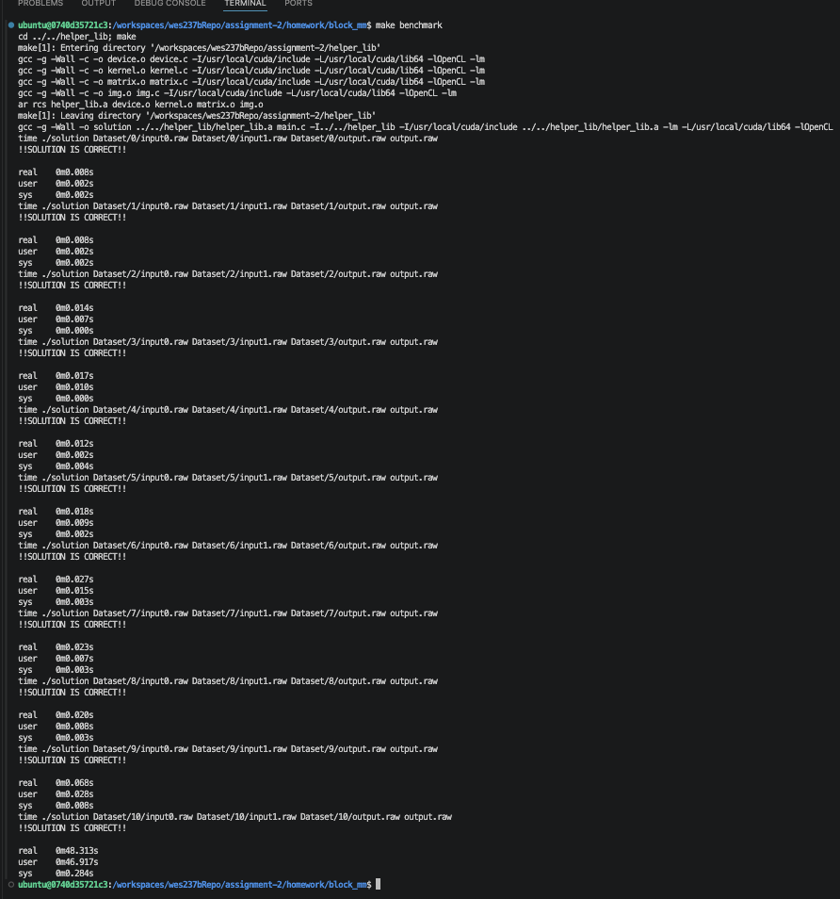

64 Block Size
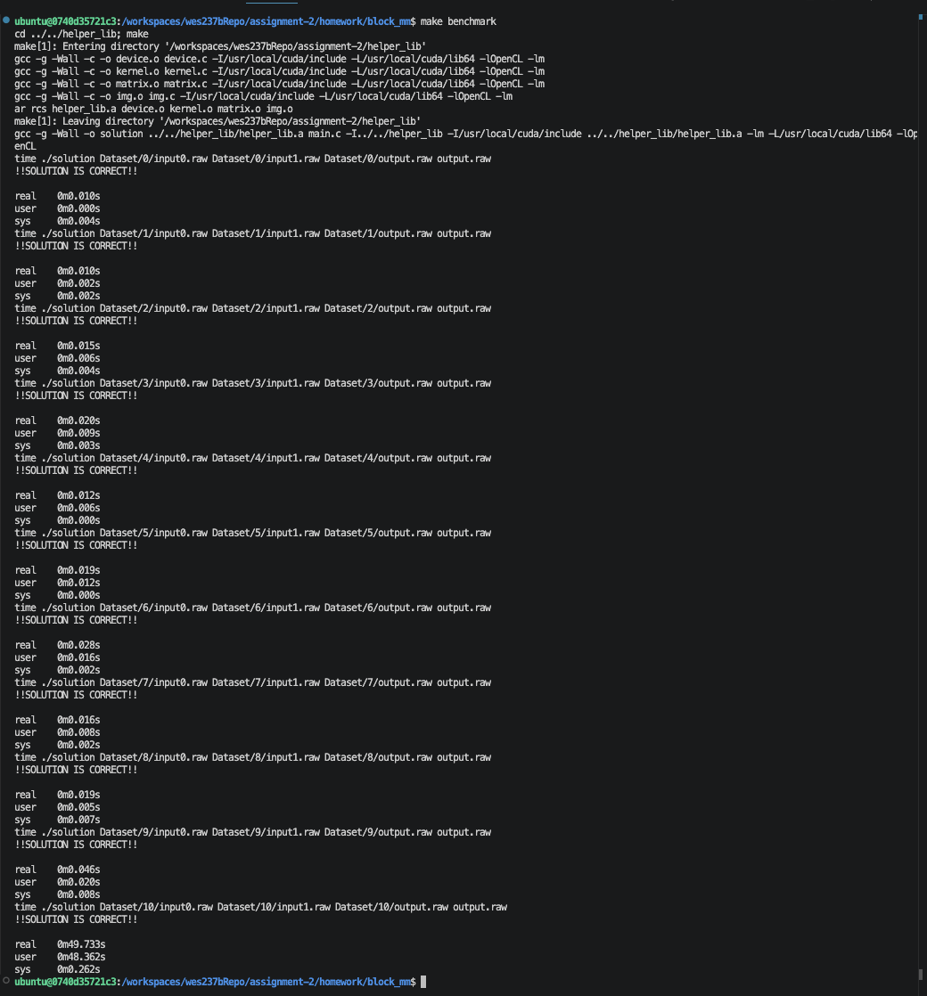

Block Size 128
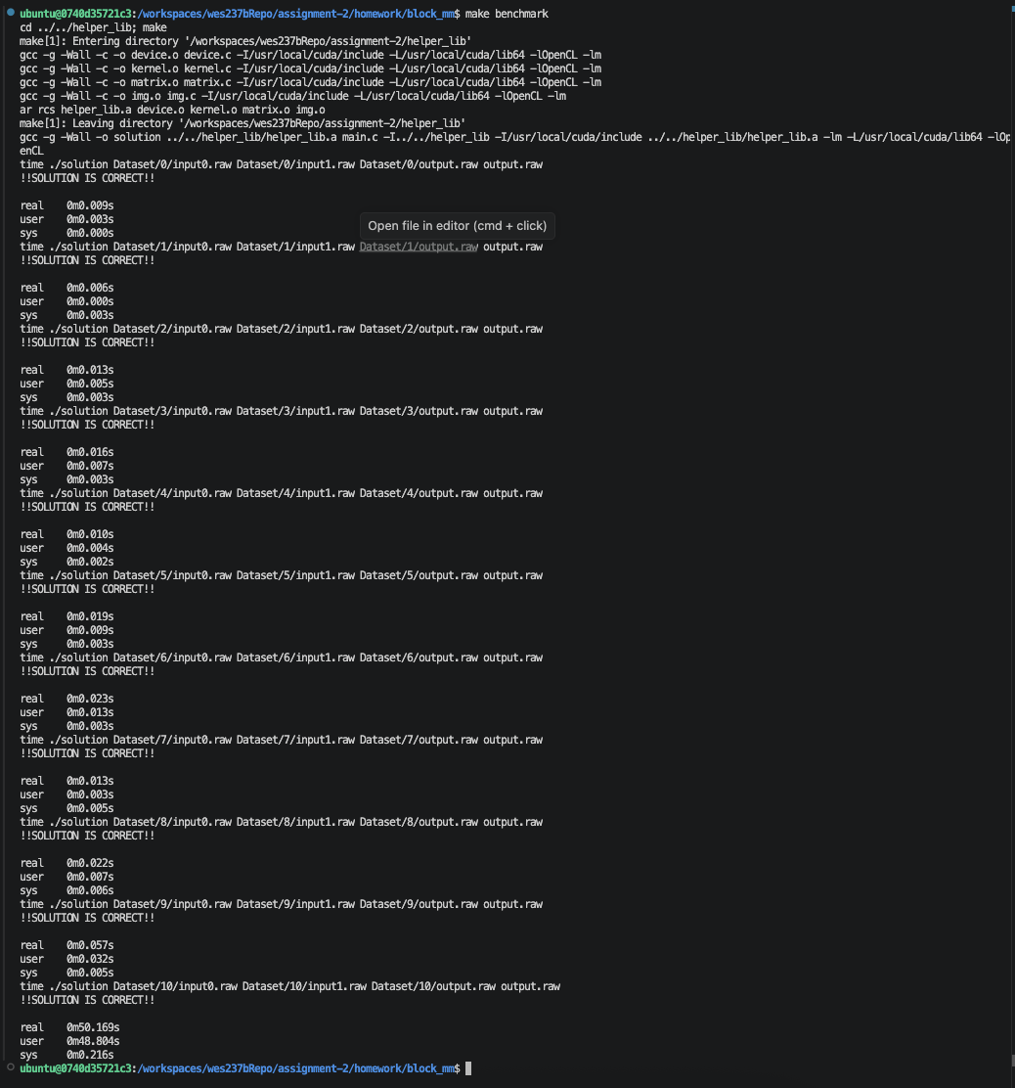

Works Cited

[1] | LLVM Project, "Clang Documentation," [Online]. Available: https://clang.llvm.org/docs/LanguageExtensions.html#loop-unrolling.

